

SINDH MADRESSATUL ISLAM UNIVERSITY (SMIU) DEPARTMENT OF SOFTWARE ENGINEERING(SE)

SPRING 2026

COURSE TITLE: INTRODUCTION TO DATA SCIENCE
SEMESTER/SECTION: BSSE 6(A,B) & BSDS 4A
COURSE CODE: CSC 218
INSTRUCTOR: MS. LARAIB WAHEED

Lab 2
Pandas Data Selection & Cleaning
Objective
- Learn how to select, filter, and clean data using Pandas.
- Understand indexing, conditional filtering, and handling missing or duplicate data.

What is Indexing?
Indexing means referring to rows and columns in a DataFrame to locate or access data. Every row in a DataFrame has a unique number (called index) starting from 0.
Example:
Index | Name | Marks
0 | Ali | 85
1 | Sara | 80
- The numbers 0 and 1 are indexes.
- We can use them to access data.
Code:
df.loc[0] # Access by label (index name)
df.iloc[1] # Access by position number

What is Selection?
Selection means choosing specific rows or columns from your dataset to view or analyze.
Example:
If your dataset has 5 columns but you only need “Name” and “Marks”:
Code:
df[['Name', 'Marks']]
This will show only those two columns.

1. Indexing & Selection
Function | Meaning | Example | What It Does
df.head() | Shows first 5 rows | df.head() | Quick preview of dataset
df.tail() | Shows last 5 rows | df.tail() | See bottom rows
df.shape | Returns (rows, columns) | df.shape | Checks dataset size
df.columns | Lists column names | df.columns | Identifies fields
df[['Name','Marks']] | Selects specific columns | df[['Name','Marks']] | View chosen columns only
df.loc[] | Label-based selection | df.loc[0:3, ['Name','Marks']] | Select rows 0-3 by labels
df.iloc[] | Position-based selection | df.iloc[0:3, 1:3] | Select by numeric positions

What is Filtering?
Filtering means showing only the rows that meet a specific condition.
For example — you only want students who scored above 80.
Code:
df[df['Marks'] > 80]
You can also combine conditions:
df[(df['Marks'] > 70) & (df['City'] == 'Karachi')]
Shows only Karachi students with Marks above 70.
Example | Meaning
df[df['Marks'] > 80] | Shows only students scoring above 80
df[df['City'] == 'Karachi'] | Filters rows where City = Karachi
df[(df['Marks'] > 70) & (df['Age'] < 20)] | Combine conditions with AND &

What is Data Cleaning?
Data cleaning means fixing or removing errors in the dataset — like missing values, wrong data, or duplicates.
Name | Marks
Ali | 85
Sara | NaN (Missing Value)
Ali | 85 (Duplicate)

Function | Description | Example
df.isnull() | Checks missing (NaN) values | df.isnull().sum() → counts per column
df.dropna() | Removes rows with NaN | df.dropna(inplace=True)
df.fillna(value) | Replaces NaN with given value | df['Marks'] = df['Marks'].fillna(df['Marks'].mean())
 | Checks for duplicates | df.duplicated().sum()
  df.duplicated()
df.drop_duplicates() |  | df.drop_duplicates(inplace=True)
  Removes duplicates

Steps to Perform in Google Colab
Step 1 – Upload Dataset
- Open Google Colab.
- Click Files → Upload and select students_lab2.csv.
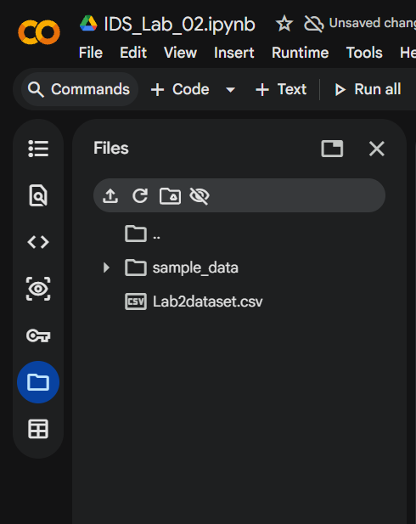
Step 2 – Import Libraries
import pandas as pd
from google.colab import files
uploaded = files.upload()
df = pd.read_csv('students.csv')
df
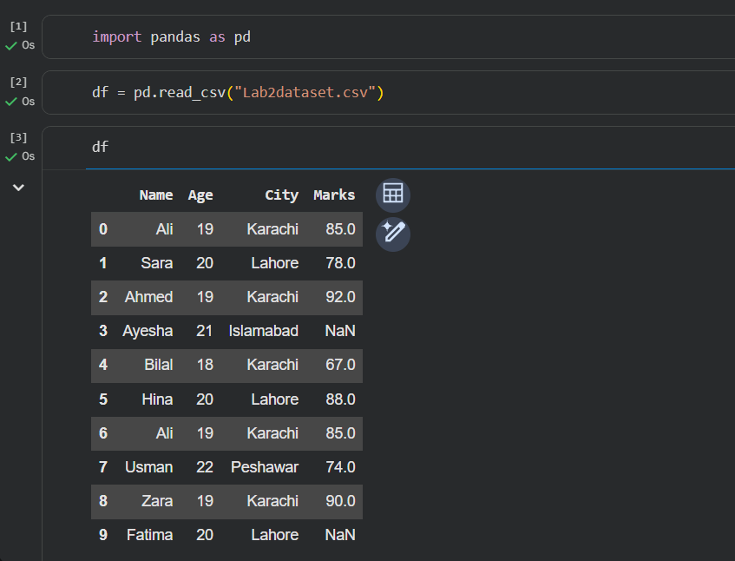
Step 3 – Read Dataset
df = pd.read_csv("students_lab2.csv")
df.head()
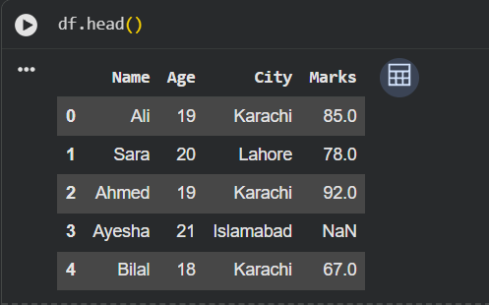
Step 4 – Explore Data
df.tail()
df.info()
df.shape
df.columns
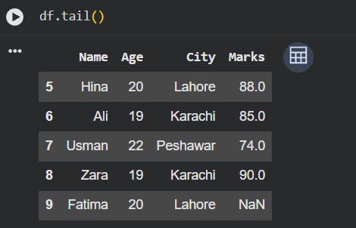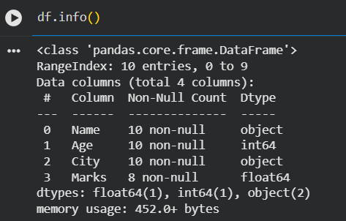
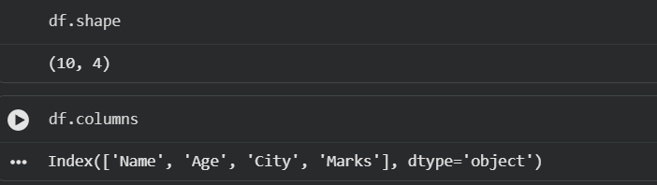

Label Based Selection (.loc)
df.loc[0]
df.loc[0:3, ['Name','Marks']]
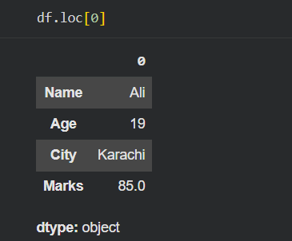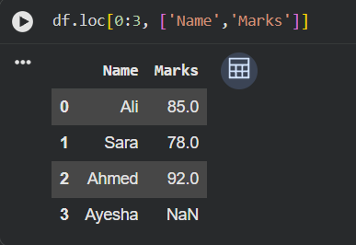

Position Based Selection (.iloc)
df.iloc[0:3, 1:3]
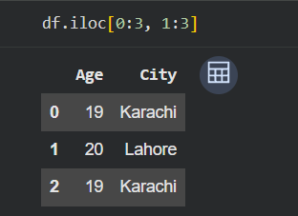
Step 5 – Select Specific Columns
df[['Name','Marks']]
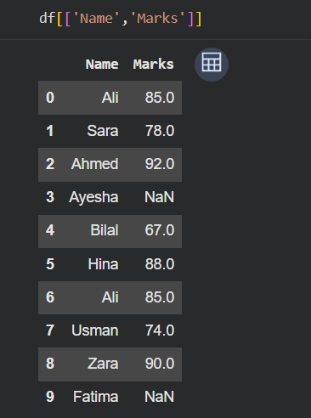
Step 6 – Filter Rows (Condition)
df[df['Marks'] > 80]
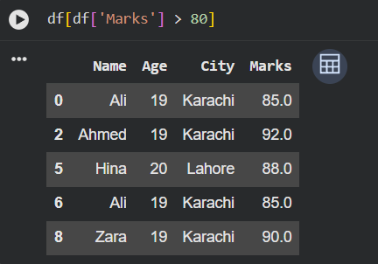
Step 7 – Check Missing Values
df.isnull().sum()
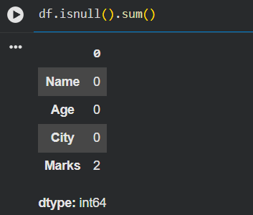
Step 8 – Handle Missing Values
df['Marks'] = df['Marks'].fillna(df['Marks'].mean())
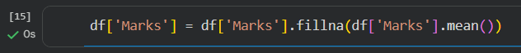
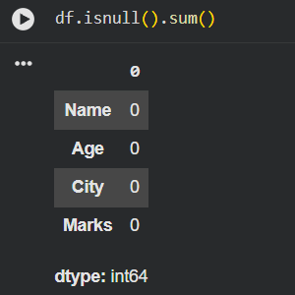
Step 9 – Check & Remove Duplicates
df.duplicated().sum()
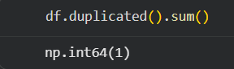
df.drop_duplicates(inplace=True)
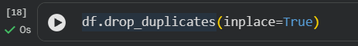
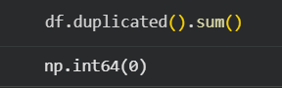
Step 10 – Final Cleaned Data
df.info()
df.head()
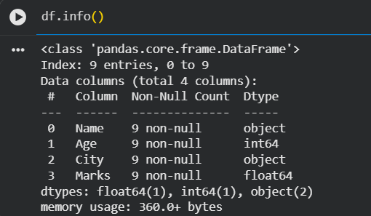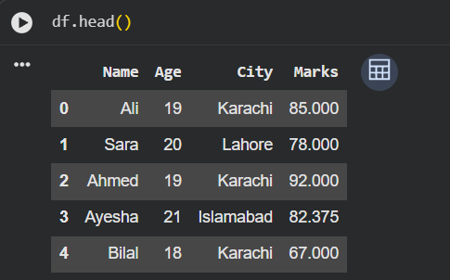

Google colab Link: https://colab.research.google.com/drive/1rpA3NZ4aocS3Wg4ozYg6CcKHe8Fn3QnD?usp=sharing

